**Finger Injury Of Shakib Al Hasan**

[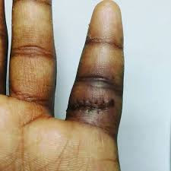](https://1.bp.blogspot.com/-6IsX0oVE7WE/W7jTB4V3epI/AAAAAAAAAKY/WNB81CnW_TEnpw0fpdKN5EpvlWQ88lnoACLcBGAs/s1600/download.jpg)

[**Shakib Al Hasan**](https://en.wikipedia.org/wiki/Shakib_Al_Hasan)hurt his **left little finger** during the ODI series against Sri Lanka in January. After that Shakib didn't play T20 and Test series against Sri Lanka. He joined the team in **March** for [Nidhahas trophy](https://en.wikipedia.org/wiki/2018_Nidahas_Trophy). For full recovery from the injury Shakib wanted to have the surgery before [**Asia Cup**](https://en.wikipedia.org/wiki/2018_Asia_Cup)

[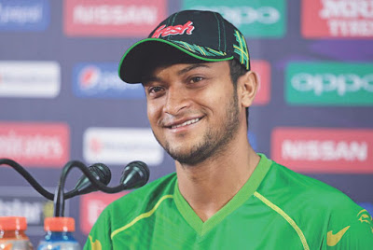](https://3.bp.blogspot.com/-rJ9Uyk50Gdc/W7jSLSoZsII/AAAAAAAAAKI/p38BGrC8HSUFmbwzy7gIGfqZyAGsbV_aQCEwYBhgL/s1600/shakib_al_hasan_15.jpg)

Here is the problem. When Shakib wanted to have the surgery [BCB](http://www.tigercricket.com.bd/) insisted him for playing Asia Cup. Because it was one of the key tournament. But it was Shakib who made the decision, which was playing the tournament for the team. Because they had a great history of Asia Cup. That's why Shakib was determined for playing.

[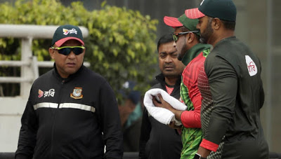](https://3.bp.blogspot.com/-o_s7WI_UbXU/W7jSVH96ybI/AAAAAAAAAKQ/GkRRcwD4ydEeybIoGx4Nm4aK-cfa55BAQCEwYBhgL/s1600/shakib_injury.jpg)

After playing some matches of Asia Cup **Shakib returned Dhaka** for having the surgery. Because he was suffering very much with that left little finger. He returned before the semi final between **Bangladesh and Pakistan**. After returning Shakib took the surgery on a short time. On that match **Bangladesh beat the Pakistan and move to the final** without [Shakib Al Hasan](https://en.wikipedia.org/wiki/Shakib_Al_Hasan).

[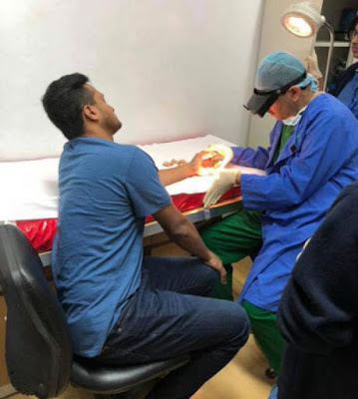](https://2.bp.blogspot.com/-5nqxzpH0ztU/W7jSjyX351I/AAAAAAAAAKM/C3NUYtgaBI4_OUC9Fz1djB5ctAYUT6sxgCLcBGAs/s1600/9a9936229463991596d74552ac4e97f9-Shakib.jpg)

When I was returning home with pain in my hand I didn't realise I would face such a terrible situation - [Facebook page of Shakib Al Hasan](https://www.facebook.com/Shakib.Al.Hasan/)

He also said that,

After coming back to home due to abnormal swelling of the hand I needed an immediate surgery done in a hospital infected pus had to be taken out from my finger

Your prayers have saved me from a great danger but I will have to do another surgery quickly -He added that.

He post a picture on his [Instagram account](https://www.instagram.com/shaki_b75/?hl=en) and shared his situation. From the injured finger puss inside came out to be **60-70cm**.

[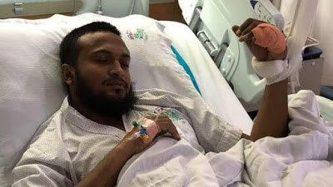](https://2.bp.blogspot.com/-fZfbgr64dZ0/W7jTVcWieEI/AAAAAAAAAKg/utI-Uw_jbekty5jgw6RVPceuR5dQ4UaUwCLcBGAs/s1600/Shakib-Al-Hasan.jpeg)

Now Shakib will fly to **Australia**or he could have fly to **USA** for further treatment. He assured that on a press briefing that **his finger won't be fixed fully**. Doctors confirmed that they will treat his finger and **Shakib will have the capability for playing cricket**. But they don't know how much time it will take for recovering from the injury.